**CITYSCHOOLS – ANALYSIS**

The CitySchools dataset is analyzed using Python’s Pandas library in Jupyter notebook. There are 15 schools in the dataset provided. Below are the conclusions drawn after analysis:

1. The top performing schools are the schools of type: **Charter**. Below table summarizes the top 5 performing schools based on overall passing rate.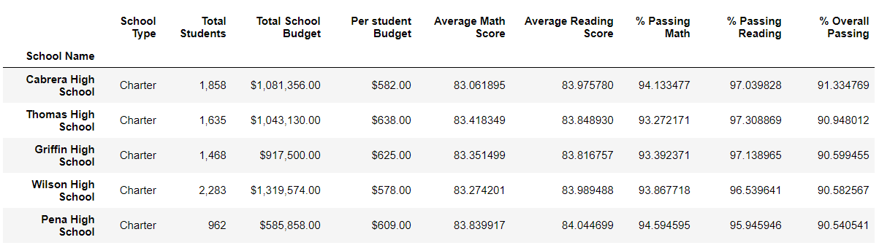



We have one more evidence to prove that charter schools are performing well.

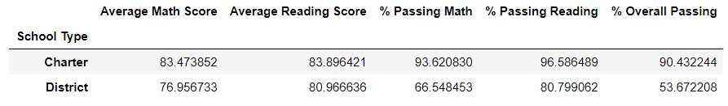



1. Surprisingly, we could see a decreasing trend in passing rate with the increase in budget amount. The schools with less budget per student has the highest overall passing rate.

